COMPUTER SCIENCE DEPARTMENT
CS0025
(SOFTWARE ENGINEERING 1)
ACTIVITY
8
[AI – ASSISTED]
UML MODELING ACTIVITY
Group Statisfied (TS31) | Target Proposal: Title 1, BetterGov
Academic Year 2026 - 2027 | November 9, 2026

I. GROUP AND PROJECT INFORMATION
Group Name: Statisfied
Members: Dawn Andrei Pamesa (Project Manager), Rogelio Porras, John Ashley Alba, Ralph Blanco
Target Proposal: A Self-Baseline Screening System for Digit Anomalies and Threshold Bunching in Philippine Public Procurement Awards
Select UML Diagram
☐ UML Case Diagram
☐ Class Diagram
☒ Sequence Diagram

Modeling Tool Used:
Mermaid (first draft). The final diagram was drawn as an SVG with a small Python script and exported to PNG with Google Chrome.

II. SYSTEM CONTEXT
Write a 150–250-word description of the proposed system. Discuss the problem being addressed, intended users, major system functions, proposed technology, dataset, and algorithm, if applicable.
System Description:
Public procurement is how the government spends public money. In the Philippines the awards are recorded in PhilGEPS and republished as open data by BetterGov. The file holds millions of award rows, so no audit team can read them all, and the usual Benford digit tests flag almost every large agency, which gives reviewers no priorities. The proposed system is a screening tool that helps reviewers decide where to look first. Its users are reviewers or auditors, and the BetterGov administrator who loads and refreshes the data. It has five modules: data ingestion and cleaning, feature engineering per agency and year, screening tests, an evaluation module that plants known manipulation to measure detection, and a dashboard. The technology is common data-processing tools for the statistics and a web dashboard prototype. The dataset is the PhilGEPS awards for 2021 to 2025 republished by BetterGov, with amount, date, procuring entity and supplier. The algorithm is a self-baseline screening procedure. S1 compares an agency's first-two-digit counts with its own previous year, and S2 compares its share of awards just below round amounts with its own previous year. The output is an anomaly score, a screening flag and an evidence summary for each agency-year, and a ranked review list. It never claims fraud. It only points to an unusual procurement pattern that needs contextual review.

III. UML DIAGRAM SELECTION
Selected Diagram
☐ Use Case Diagram | – represents the actors, system scope, and major system functions.
☐ Class Diagram | – represents the classes, attributes, methods, and structural relationships within the system.
☒ Sequence Diagram | – represents the sequence of interactions involved in an important system process or algorithm.

Selected Diagram
Sequence Diagram

Justification for the Selected Diagram
Explain why the selected UML diagram is appropriate for your target proposal.
A sequence diagram fits the BetterGov screening system because the important thing is the order of the steps and who sends what to whom. Records are collected, cleaned, turned into features, compared with the agency's own previous year, and then shown to the reviewer as a ranked list. A use case diagram would only list the users and functions, and a class diagram would only show structure. Neither shows the order of the screening process or the two special cases it must handle, which are invalid data and an agency with no previous-year record.

IV. IDENTIFIED UML COMPONENTS
Complete only the section corresponding to your selected diagram.
OPTION A: USE CASE DIAGRAM
Not used. The selected diagram is a Sequence Diagram.

OPTION B: CLASS DIAGRAM
Not used. The selected diagram is a Sequence Diagram.

OPTION C: SEQUENCE DIAGRAM

Actor / Object | Role in the Process | Important Message or Action
BetterGov Administrator | Uploads, manages or updates the procurement dataset and may start the screening process. | Start data refresh (message 1).
Reviewer or Auditor | Selects an agency and year, views anomaly scores, examines evidence, and uses the ranked results to decide which records need further review. | Select agency and year (9). Receives scores and flags (22).
BetterGov / PhilGEPS Data Source | Provides procurement award records such as award amount, date, procuring entity and supplier. | Sends the award records (3).
Dashboard | Lets the user submit requests and view charts, screening flags, anomaly scores and evidence summaries. | Request screening (10). Show scores and flags (22).
Screening System | Coordinates the data retrieval, cleaning, analysis and generation of the screening results. | Requests records (2), asks for cleaning (4), stores results (6, 8, 20), asks for features (13), returns the ranked list (21).
Data Cleaning Module | Removes duplicates, checks missing values, validates dates and prepares the procurement records. | Returns cleaned records (5) or rejected records with reasons (7).
Analysis Module | Calculates the digit-pattern, rounding and threshold-bunching indicators and the year-to-year comparison. | Gets the previous-year profile (14), runs the S1 and S2 tests (16), returns the score, flag and evidence (17) or not screened (19).
Database | Stores procurement records, agency information, calculated indicators, anomaly scores and screening results. | Returns agency-year records (12), the previous-year profile (15) or no record found (18).

Sequence No. | Sender | Receiver | Message or action
1 | BetterGov Administrator | Screening System | Start data refresh
2 | Screening System | Data Source | Request award records
3 | Data Source | Screening System | Award records
4 | Screening System | Data Cleaning Module | Clean and validate records
5 | Data Cleaning Module | Screening System | Cleaned records (alt: records are valid)
6 | Screening System | Database | Store cleaned records (alt: records are valid)
7 | Data Cleaning Module | Screening System | Rejected records with reasons (alt: invalid or missing data)
8 | Screening System | Database | Log rejected records (alt: invalid or missing data)
9 | Reviewer or Auditor | Dashboard | Select agency and year
10 | Dashboard | Screening System | Request screening
11 | Screening System | Database | Get agency-year records
12 | Database | Screening System | Agency-year records
13 | Screening System | Analysis Module | Compute digit, rounding and near-threshold features
14 | Analysis Module | Database | Get previous-year profile
15 | Database | Analysis Module | Previous-year profile (alt: previous-year record exists)
16 | Analysis Module | Analysis Module | Run S1 and S2 tests (alt: previous-year record exists)
17 | Analysis Module | Screening System | Anomaly score, flag and evidence (alt: previous-year record exists)
18 | Database | Analysis Module | No record found (alt: no previous-year record)
19 | Analysis Module | Screening System | Not screened, no baseline (alt: no previous-year record)
20 | Screening System | Database | Store screening result
21 | Screening System | Dashboard | Ranked review list
22 | Dashboard | Reviewer or Auditor | Show scores and flags

V. UML DIAGRAM
Insert a clear and high-resolution copy of the UML diagram below.
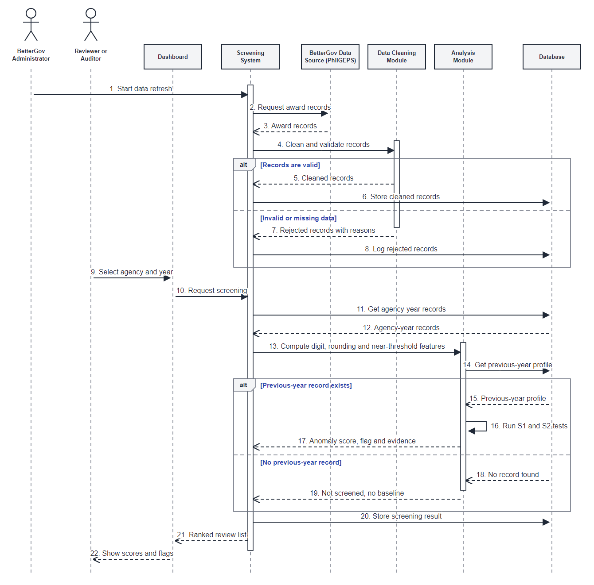
Figure 1. Sequence Diagram of the BetterGov Self-Baseline Screening Process
VI. DIAGRAM EXPLANATION
A. PURPOSE OF THE DIAGRAM
Write a 300–500-word explanation of the UML diagram.
This sequence diagram shows how the BetterGov screening system turns raw procurement awards into a ranked list that a reviewer can use. It follows one complete run in order from top to bottom. The first part is the data refresh. The BetterGov administrator starts it, the Screening System asks the BetterGov and PhilGEPS data source for the award records, and the Data Cleaning Module checks them. Valid records are stored in the database. Invalid or missing records are rejected with reasons and logged, so bad rows never reach the analysis. The second part is the screening request. The reviewer picks an agency and a year in the dashboard, and the Screening System gets that agency's records from the database. The Analysis Module then computes the digit, rounding and near-threshold features and looks for the agency's profile from the previous year. If a previous-year record exists, the module runs the S1 digit test and the S2 bunching test against the agency's own previous year and returns an anomaly score, a screening flag and an evidence summary. If there is no previous-year record, the agency is marked as not screened because it has no baseline. The Screening System stores the result and sends a ranked review list to the dashboard, which shows the scores and flags to the reviewer. The purpose of the diagram is to make this order clear before the system is built. It shows who sends each message, what is stored, and where the two special cases are handled. It also keeps the main idea of the proposal visible: the system only screens, and every flag is a reason for a human to look closer, never a finding of fraud. Each message in the diagram is numbered, so the group and the reviewer can follow the order step by step. Drawing the process first also lets the group check that nothing in the proposal is missing before any code is written.

B. MAJOR COMPONENTS
Identify and explain the important actors, use cases, classes, objects, methods, or messages shown in the diagram.
Actors: the BetterGov Administrator starts the data refresh, and the Reviewer or Auditor selects an agency and year and reads the results. Objects: the Dashboard is the screen the reviewer uses; the Screening System coordinates every step; the BetterGov and PhilGEPS Data Source provides the award records; the Data Cleaning Module validates them; the Analysis Module computes the features and runs the S1 and S2 tests; and the Database stores records, indicators and results. Key messages: Start data refresh (1), Clean and validate records (4), Request screening (10), Compute features (13), Run S1 and S2 tests (16), and Ranked review list (21).

C. RELATIONSHIPS OR INTERACTIONS
Explain the relationships or interactions among the components.
There are two flows. In the data refresh flow (messages 1 to 8), the Screening System gets records from the data source, passes them to the Data Cleaning Module, and stores the clean or rejected records in the database. In the screening flow (messages 9 to 22), the dashboard passes the reviewer's request to the Screening System, which reads the records from the database and hands them to the Analysis Module. The Analysis Module reads the previous-year profile from the database and sends its result back to the Screening System. The Screening System is the center of both flows. The other modules never talk to the reviewer directly. The two alt fragments show the two decisions: valid or invalid records, and previous-year record or none.

D. ALIGNMENT WITH THE TARGET PROPOSAL
Explain how the diagram represents the objectives and requirements of the target proposal.
The diagram shows the proposal's modules in action: data ingestion and cleaning (messages 2 to 8), feature engineering (13), the screening tests S1 and S2 (14 to 19), and the dashboard (9, 10, 21, 22). It follows the self-baseline idea, which compares each agency with its own previous year, and it shows that an agency with no baseline is not screened, as the proposal requires. The output is an anomaly score, a screening flag and an evidence summary, and the list is a ranked review list, not a fraud finding. The evaluation module, which plants known manipulation to measure detection, is not part of the reviewer's flow, so it is not shown.

E. ALGORITHM, DATASET, OR TECHNICAL PROCESS
Explain how the proposed algorithm, dataset, AI model, or technical process is represented in the diagram. Write Not Applicable if the proposal does not include these components.
The dataset comes in through messages 2 and 3, when the Screening System requests the PhilGEPS award records that BetterGov republishes. Messages 4 to 8 apply the cleaning rules. Messages 11 and 12 get the agency-year records, and message 13 computes the digit counts, rounding shares and near-threshold counts. Messages 14 to 19 are the algorithm: the Analysis Module gets the agency's previous year and runs S1 (first-two-digit counts) and S2 (share of awards just below round amounts) against it. The result goes back as the anomaly score, flag and evidence in message 17. No machine-learning model is used.

F. MAJOR DESIGN DECISIONS
Design Decision 1: One Screening System coordinates, with separate cleaning and analysis modules.
Justification: This matches the proposal's modules, keeps each module to one job, and lets the cleaning rules change without touching the tests.
Design Decision 2: The previous-year comparison happens in the Analysis Module, with an alt fragment for agencies that have no previous-year record.
Justification: The self-baseline test needs a baseline, and the proposal says agencies without one are labelled not evaluated, never normal or low risk.

VII. VALIDATION OF THE UML DIAGRAM
VALIDATION OF THE UML DIAGRAM

Validation Area | Group's Evaluation
Alignment with the target proposal | The sequence diagram aligns with the proposed BetterGov screening system because it shows the process of retrieving procurement data, cleaning and validating the records, calculating digit-pattern and threshold-bunching indicators, comparing an agency with its previous year, and displaying the resulting anomaly scores and screening flags.
Completeness of the diagram | The diagram includes the main actors and system components involved in the screening process: the reviewer or auditor, the administrator, the dashboard, the screening system, the data source, the data cleaning and analysis modules, and the database. It represents the major messages from selecting an agency and year to displaying the final ranked review results.
Accuracy of UML notation | The sequence diagram follows the correct UML structure by using lifelines for actors and objects, activation bars for active processing, arrows for messages, and chronological ordering from top to bottom. The messages are arranged logically: data retrieval occurs before cleaning, cleaning occurs before analysis, and analysis occurs before results are displayed.
Consistency with system requirements | The diagram matches the requirements in the proposal: the data is cleaned before it is analyzed, each agency is compared with its own previous year, and the output is an anomaly score, a screening flag and an evidence summary in a ranked list. It never states that fraud happened.
Feasibility of the modeled functions | The modeled functions are feasible because they use publicly available procurement records and established statistical screening procedures. Data cleaning, feature engineering, digit analysis, threshold-bunching analysis, database storage, and dashboard presentation can be implemented using common data-processing and web-development technologies.
Representation of the algorithm or technical process | Messages 13 to 19 show the algorithm: the features are computed, the previous-year profile is read, and the S1 digit test and S2 bunching test run against it. Agencies with no previous-year record are shown as not screened. The offline evaluation module is not shown because it is not part of the reviewer's flow.
Identified limitation or possible revision | The diagram shows the normal process and not every error case. The group first noted that it should include an alt fragment for invalid or missing data, an alt fragment for an agency with no previous-year record, and a clear statement of who uploads the data. These revisions were made: the final diagram has both alt fragments and the BetterGov Administrator as the actor who starts the data refresh.

VIII. AI INTERACTION LOG
Complete this section if the group used an AI tool.
AI INTERACTION LOG

No. | AI Tool Used | Prompt or Instruction Given | AI-Generated Suggestion | Group's Validation or Revision
1 | ChatGPT | Asked how to answer the validation table and the actor list for the sequence diagram. | Draft answers for the validation rows and the actors with their roles. | Ashley checked the answers herself against the diagram and the proposal.
2 | Claude | Asked to draw a sequence diagram of the screening process from the approved proposal and the group's actor list. | A first draft with eight lifelines and two alt fragments, written in Mermaid. | Dawn checked it against the proposal and the group's notes.
3 | Claude | Asked to redraw the diagram in a plain, standard UML style after the first draft looked too generic. | A redrawn diagram with numbered messages, activation bars and alt frames. | Dawn checked the order of the messages and the labels.
4 | Claude | Asked to fill the system context, the explanation, the design decisions and the other table rows from the proposal. | First drafts of those sections. | The group checked each fact against the proposal.
5 | Claude | Asked to put everything into the assessment sheet. | The completed sheet. | Dawn checked it before submission.

AI-GENERATED CONTENT EVALUATION
Which AI suggestions were accepted? Why?
We accepted the two alt fragments, the administrator actor, and the numbered message table because they match the proposal's modules and the group's notes.
Which AI suggestions were rejected or revised? Why?
We rejected the first diagram style because it looked too generic, so it was redrawn. We shortened long message labels so they fit, and removed any number that is not in the proposal.
How did the group verify the technical accuracy of the AI-generated suggestions?
We compared every message and number with the proposal and checked the UML notation: lifelines, activation bars, arrow types and alt frames.

IX. AI USAGE DECLARATION
Select and sign the appropriate declaration.
If AI Was Used
☒ We declare that AI tools were used only to assist in brainstorming, reviewing, and improving selected parts of this assessment. All AI-generated suggestions were evaluated, verified, and revised by the group. The group accepts full responsibility for the accuracy, originality, and quality of the final output.
If AI Was Not Used
☐ We declare that no generative AI tool was used in creating this assessment. The UML diagram, explanations, and supporting content were developed and reviewed by the group members.
Group Leader's Name and Signature: Dawn Andrei Pamesa
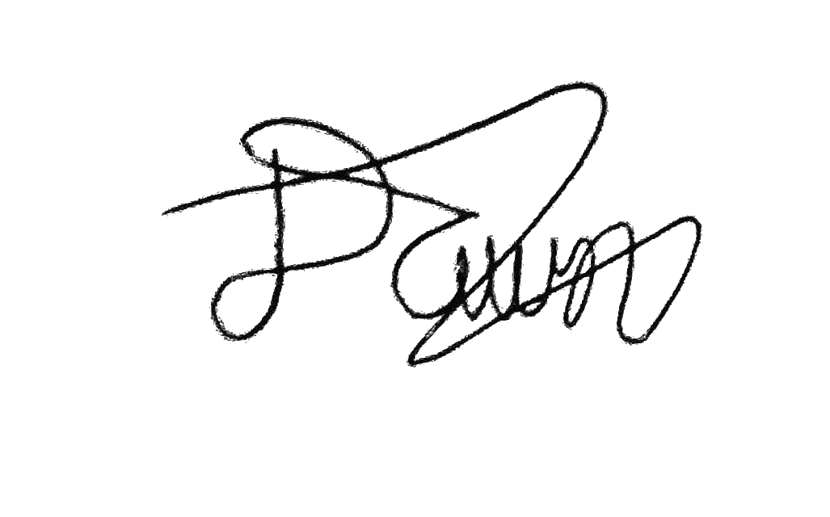

Date: November 9, 2026
X. TEAM CONTRIBUTION MATRIX
TEAM CONTRIBUTION MATRIX

Group Member | Assigned Task | Specific Contribution | Contribution Percentage
1 Dawn Andrei Pamesa (Project Manager) | Sequence diagram, system context, explanation, AI log, assembly and submission | Directed and checked the diagram and the write-ups, assembled the document, submits on Canvas | 30%
2 Rogelio Porras | Actor list and validation table (helped Ashley), review | Helped Ashley with the answers and reviewed the document | 23%
3 John Ashley Alba | Validation table and actor list | Wrote the validation answers and the actor list | 23%
4 Ralph Blanco | Validation table (helped Ashley), review | Helped Ashley with the answers and reviewed the document | 24%
Total |  |  | 100%

XI. REFERENCES
REFERENCES

1. Barney, B. J., & Schulzke, K. S. (2016). Moderating "cry wolf" events with Excess MAD in Benford's law research and practice. Journal of Forensic Accounting Research, 1(1), A66-A90. https://doi.org/10.2308/jfar-51622
2. BetterGov. (n.d.). BetterGov transparency dashboard. Retrieved October 30, 2026, from https://transparency.bettergov.ph/
3. Nigrini, M. J. (2012). Benford's law: Applications for forensic accounting, auditing, and fraud detection. John Wiley & Sons. https://doi.org/10.1002/9781119203094
4. Object Management Group. (2017). Unified Modeling Language (UML), version 2.5.1 (formal/17-12-05).
5. Philippine Government Electronic Procurement System. (n.d.). PhilGEPS open data. Retrieved October 30, 2026, from https://open.philgeps.gov.ph/analytics/
SUBMISSION CHECKLIST
Before submitting, verify that the document contains the following:
☒ Cover Page
☒ Complete group and project information
☒ System context
☒ Justification for the selected UML diagram
☒ Complete and readable UML diagram
☒ Correct UML notation
☒ Diagram explanation
☒ Validation table
☒ AI Interaction Log, if applicable
☒ AI Usage Declaration
☒ Team Contribution Matrix
☒ References, if applicable
☒ PDF version of the complete assessment
☒ High-resolution copy of the UML diagram
Required File Name:
TA8_Statisfied_BetterGov_UML.pdf
Submission: The group leader must submit the completed assessment through Canvas LMS.

